**Reply Letter**

Jan. 31, 2016

Dear Editor:

Thank you for your letter dated Jan. 12, 2016 and your comments on the paper entitled “An approach to achieving optimized complex sheet inflation under constraints” for the Journal of Computers & Graphics. The paper has been carefully revised in order to accommodate the reviewers’ suggestions and comments. New figures and paragraphs are added to the introduction section to explain some concepts (sheet, sheet inflation and quad set), the importance of the sheet inflation, and the motivation of our work. Many sentences are revised according to the reviewers’ comments. A new example of Stanford Bunny is also added to Section 6.1. The following is a point-by-point response/revision summary:

**For Reviewer 1:**

***Comment 1.1****:*

*Fix the abstract. For example, start the abstract with something like "Sheet inflation is an enhanced and more general version of the classic pillowing [reference] procedure used to modify hexahedrdal meshes. The flexibility of sheet inflation makes it a valuable tool for hex mesh generation, modification and topology optimization. However, it is ..." This will give the reader some immediately context as to what.*

**Response**:

Thank you very much for your comments and suggestions. The abstract has been revised and the reference about pillowing has been added.

***Comment 1.2:***

*On line 15 of the introduction, add a reference to staten's work on sheet inflation. Also add references for sheet extraction, dicing and column collapsing on this line. Also add pillowing to this line.*

**Response:**

All the references you mentioned have been added.

***Comment 1.3:***

*Fix Figure 1:*

*3A. Figure 1 and 2 are basically duplicates of each other. There is no need for both. Consolidate them into a single figure.*

*3B. Figure 1 is very small, and difficult to visualize. Make this figure bigger.*

*3C. Choose a different color scheme on Figure 1A, so you have more contrast. Currently it is black mesh edges on dark grey quads, makes it difficult. How about black mesh edges on yellow.*

*3D. Add a Figure 1D, which shows the mesh in full-shaded just like figure 1A, but after the sheet is inserted. Figure 1C is difficult to understand.*

**Response:**

Thanks for your comments. To make the figures here illustrate the related contents better, in the revised version, the previous two figures have been redrawn according to your suggestions:

1. The two figures are replaced by a single figure;
2. The figure is now bigger with a simpler mesh model to provide better visualization;
3. The color scheme has been changed to black mesh edges on yellow quads;
4. A full-shaded subfigure has been added showing the hex mesh after sheet inflation.

The new figure is shown below:

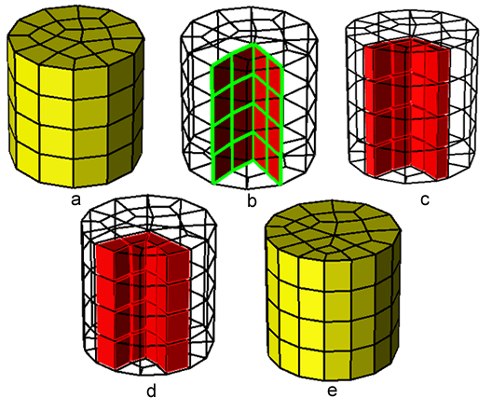

Figure 2: The procedures of sheet inflation: (a) the hex mesh before sheet inflation; (b) the quad set for sheet inflation; (c) the new sheet is created by inflating the quad set; (d) the new sheet is created; (e) the hex mesh after sheet inflation.

**Comment 1.4:**

*Add a paragraph with some text which describes what sheet inflation is. Currently all you say is "The common procedures of sheet inflation are shown in Fig. 1". Add a full paragraph that describes what a quad set is, how it compares to pillowing, etc. Because sheet inflation is the back-bone of your paper, the reader needs to understand what it is without having to go searching for references.*

**Response:**

Thanks for your suggestion. To make the reader easily understand sheet inflation, we add the following paragraph in the introduction to describe what sheet inflation is, what the quad set for sheet inflation is, and how it compares to pillowing:

“Sheet inflation takes a continuous quad set as input and generates a new sheet by inflating the quad set. The process of the sheet inflation is illustrated in Fig. 2. This continuous quad set (Fig. 2(b)) is called the quad set for sheet inflation (or quad set if not ambiguous in the context) which is provided by other procedures or specified directly by the user. Sheet inflation splits the nodes, edges and quads on the quad set (Fig. 2(b)), and then form new hexahedra by connecting corresponding the new nodes (Fig. 2(c) and Fig. 2(d)). The process of the sheet inflation shows that the quad set is critical for sheet inflation because it determines the position, shape and topology of the sheet to be generated by the sheet inflation. And compared with pillowing, sheet inflation is more flexible and versatile, having the potential ability to create any kind of sheets, provided that a suitable quad set can be deter- mined. Therefore sheet inflation can be used to support various hex mesh modification.”(Sec. 1)

**Comment 1.5:**

*You mention "the quad set" in the caption of Figure 1, but have not introduced it.  Explain why a quad set is needed for sheet inflation, and where it comes from.*

**Response:**

Thanks for your comment and suggestion. We add a paragraph explaining why a quad set is needed for sheet inflation and where it comes from, which has been given in the response for Comment 1.4.

**Comment 1.6:**

*The introduction currently contains no motivation for why the reader will care about sheet inflation. Add some description about what it is used for so the user will understand "why" we need sheet inflation to work better for self-intersecting sheets.*

**Response:**

Thanks for your comment and suggestion. To explain our motivation clearly, we first give an example at the beginning of introduction in Figure 1, showing why dual operations are useful for hexahedral mesh modification. Then we explain that sheet inflation is quite flexible and versatile for creating various sheets for different kinds of mesh modification, and use a real example to show how sheet inflation can be utilized to effectively modify the hexahedral mesh boundary as shown in Figures 3, 4 and 5. Also, we give an example, as shown in Figure 6, where self-intersecting sheets are needed to be inflated in order to reduce the high valence. This example can help the reader understand why we need sheet inflation to work better for self-intersecting sheets. The new paragraphs and figures added are given below:

“Figure 1 shows an example that even though we want to make small local modification as adding one new quad to the boundary of the hex mesh (Fig. 1(b)), a circle of quads on the boundary (Fig. 1(c)) as well as a set of hex have to be generated in order to keep the hex mesh valid (Fig. 1(d)). The dual structures, which contribute to the global connectivity of hex meshes, are called sheets. The set of hex in Fig. 1(d) is actually a sheet.

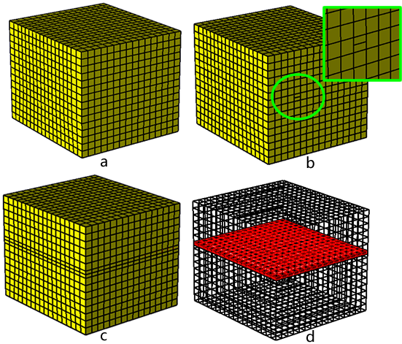

Figure 1: An example of local modification resulting in global change: (a) the original hex mesh; (b) local modification by adding a quad on the mesh boundary; (c) a circle of quads on the mesh boundary have to be added; (d) a set of hexahedra have to be added.

...

Sheet inflation is a flexible and versatile sheet operation that can create various and complex sheets, and thus it can be utilized to effectively support many hex mesh modification scenarios. One common scenario is to use sheet inflation to locally change the mesh topology, especially the boundary topology of a hex mesh. In this scenario, new sheets usually need to be created to satisfy certain constraints like at the specified position within a delimited region. As the quad set plays a key role for sheet inflation, the main difficulty to achieve this is how to construct a qualified quad set under the given constraints. In practice, these constraints are normally specified by a set of boundary edges and a set of hexahedra. The former determines the positions where the new sheet should appear on the mesh boundary, and the latter delimits the region where the new sheet belongs to.

Figure 3 shows an example where such constrained sheet inflation is required. In this example, the hex mesh (Fig. 3a) contains one boundary node whose valence is 6 and it is undesirable. As shown in Fig. 3b., this high valence can be reduced by splitting the node into two nodes with lower valences, and a constrained sheet inflation can be used to achieve this. Specifically, two mesh edges adjacent to the high-valence node are selected as the position constraint of the new sheet (Fig. 4a) first, then a quad set is constructed (Fig. 4b), finally the new sheet is inflated based on the quad set (Fig. 4c)). The result is shown in Fig. 4e.

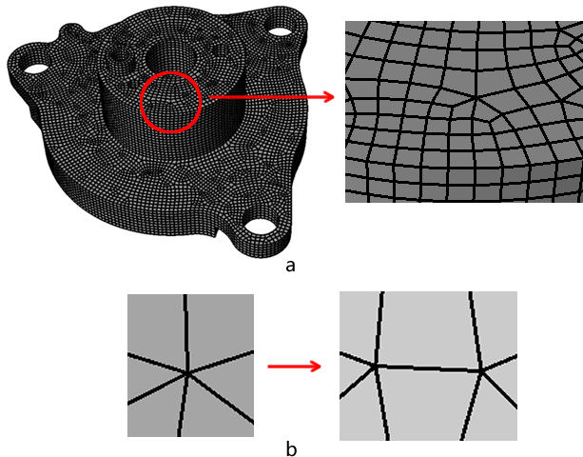

Figure 3: An example where boundary modification is required: (a) the hex mesh with a high-valence node; (b) the high valence is reduced by splitting the node into two nodes.

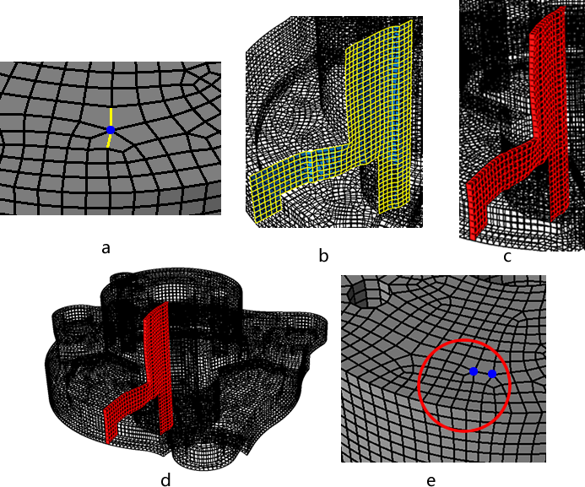

Figure 4: Reducing high valence by non-localized sheet inflation: (a) selected mesh edges where new sheet needs inflating; (b) the quad set for sheet inflation without local consideration; (c) the new sheet; (d) the high valence is improved.

Without region constraints being specified, the quad set may spread uncontrollably through the hex mesh, e.g. the quad set in Fig. 4(b). Inflating quad sets like this will impact almost the whole mesh. To localize the sheet inflation, region constraints need specifying by a set of hexahedra (yellow in Fig. 5(a)). The quad set is then constructed within that delimited region (Fig. 5(b)). Compared to Fig. 4(d), the localized sheet inflation will impact only a limited part of the hex mesh as shown in Fig. 5(d).

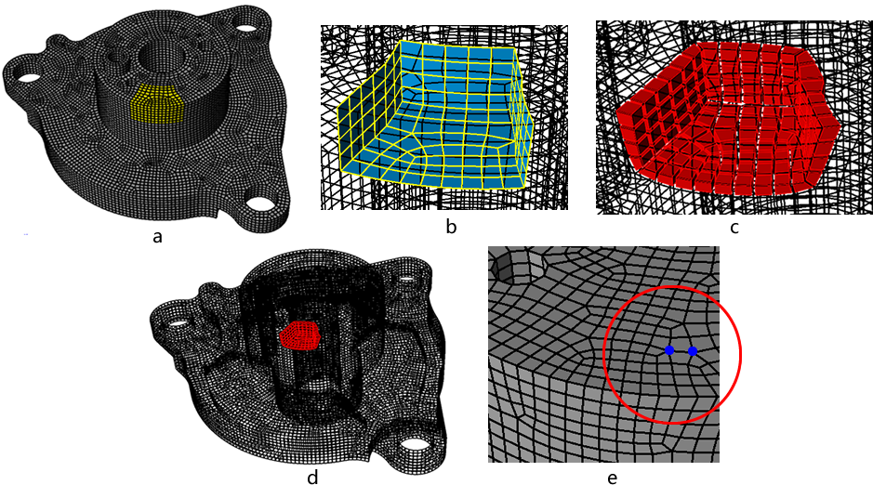

Figure 5: Reducing high valence by localized sheet inflation: (a) delimited region specified by a set of hex (yellow); (b) the localized quad set for sheet inflation; (c) the new sheet; (d) the new sheet is localized to the whole mesh; (e) the high valence is improved.

…

Despite these achievements, to inflate complex sheets under various constraints, especially to generate self-intersecting sheets within a local region, is still very difficult. Furthermore, how to assure the mesh quality for complex sheet inflation is also a challenging problem. Here it should be pointed out that in many situations it is imperative to locally create self- intersecting sheets. For the example in Fig. 6(a), where a nodes valence is 7, splitting method shown in Fig. 3(b) can not effectively reduce the high valence since the valence of one new node is still 6 (Fig. 6(b)). Thus, instead of selecting two adjacent edges, four adjacent edges need to be selected and the node needs to be split into four nodes as shown in Fig. 6(c), which requires a self-intersecting sheet be generated. Since the edge valences (the number of the quads that are adjacent to the edge) have significant impact on the quality of quad mesh and hex mesh[16], we use the irregular degrees (the edges valence variance from a regular edge) of the quad set[18] to measure its quality in this work.

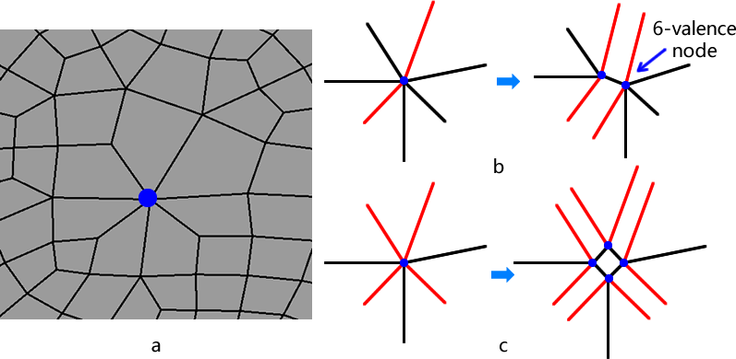

Figure 6: An example when a self-intersecting sheet is required to be generated: (a) the hex mesh with a high-valence node; (b) the high valence is reduced by splitting the node into four nodes.

”(Sec.1)

**Comment 1.7:**

*Figure 3 again is too small. In every paper I've read from these authors, their figures are too small. Why can't Figure 3 be 2 rows, rather than 1*

**Response:**

Thanks for your comment and suggestion. This figure has been revised as below:

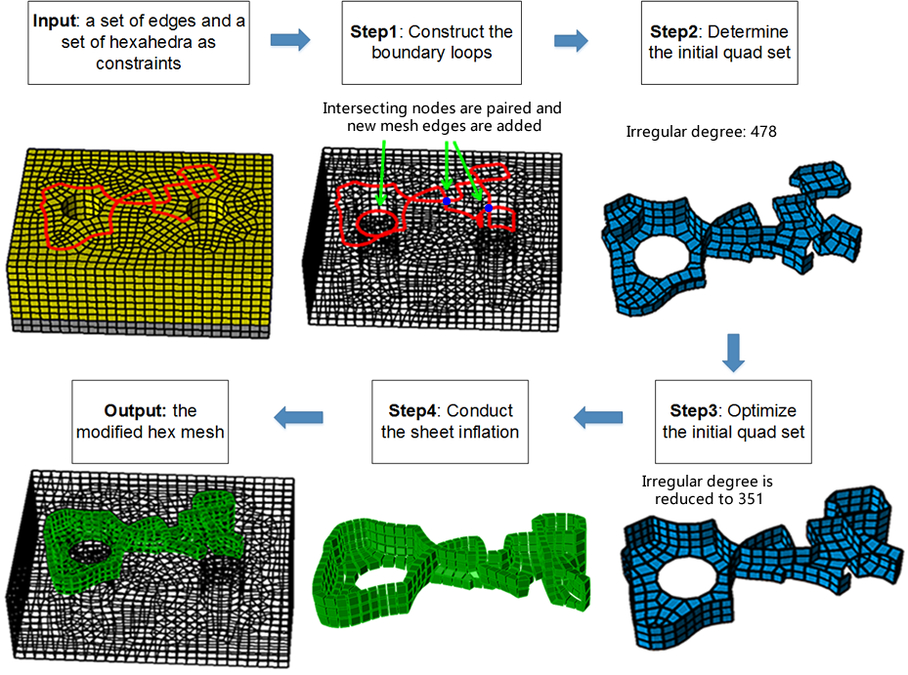

**Comment 1.8:**

*Figure 3-Step 1 mentions a "set of hexahedra as constraints" but there is no explanation as to where this set comes from. Why not use all the hexes in the mesh?*

**Response:**

The hexahedra set refers to the delimited region where the new sheet belongs to. It is specified by the user and used to achieve local sheet inflation. We have added the above two sentences in the first paragraph of Sec. 2. This paragraph now becomes as below:

“In this paper, an approach is proposed to achieving complex sheet inflation under various constraints while assuring the mesh quality. It takes a set of boundary mesh edges and a set of hexahedra as input. The edges specify the boundary position where the new sheet should appear. The hexahedra set refers to the delimited region where the new sheet belongs to. It is specified by the user and used to achieve local sheet inflation. Under these constraints, it constructs a qualified quad set and then creates the new sheet as output. …” (Sec. 2)

**Comment 1.9:**

*Line 50-51: "... makes Pillowing prevailing ..." should be "... makes Pillowing prevalent ..."*

**Response:**

Thanks for your suggestion. The sentence has been revised according to your suggestion.

**Comment 1.10:**

*Line 85, what boundary loop? You haven't defined this yet.*

**Response:**

The boundary loop refers to the loop formed by all the mesh edges of a quad set that are on the hexahedral mesh boundary. We add a sentence to the second last paragraph to explain this:

“… For a quad set, all its mesh edges on the hex mesh boundary form a loop/loops, called the quad set’s boundary loop/loops….” (Sec.1)

**Comment 1.11:**

*I had to stare at Figure 6 for a very long time (5-10 minutes) before I understood it. Can you simplify this, or add more explanation text? I still don't understand what you mean by "template" in this context. Do you mean "cases" instead of template?*

**Response:**

Sorry for not explaining it clearly. We have revised that part and now use “local intersecting structures” instead of “template”. The revised paragraphs and figure captions are as follows:

“…Based on the observation about the structures of quadrilateral sets, we introduce two types of local intersecting structures that can be used to effectively pair intersecting nodes. By recursively searching these two types of local intersecting structures from the input boundary mesh edges, properly pairing of intersecting nodes can be achieved.

On various intersecting quad sets, two types of local intersecting quad subsets are observed, which are shown in Fig. 10(a) and Fig. 10(f). These two types of quad subsets both have one intersecting line and two intersecting nodes on their boundary loops. The topological structures of their boundary loops are shown in Fig. 10(d) and Fig. 10(i). Conversely, if a local intersecting structure of the mesh edges is found to share the same topology with that shown in Fig. 10(d) or Fig. 10(i), there should be a corresponding local intersecting quad subset. Hence, it is reasonable to pair the two intersecting nodes on this local part of the mesh edges, which will not result in the improper pairing mentioned in [16].

To recursively find next pair of intersecting nodes, the local topological structures are modified accordingly as shown in Fig. 10(e) and Fig. 10(j). Currently, we use a depth-first strategy to search and handle the two types of local intersecting structures, which means if we find a local intersecting structure, we pair the two intersecting nodes involved in the structure and modify this local intersecting structure at once until no more intersecting nodes can be paired.

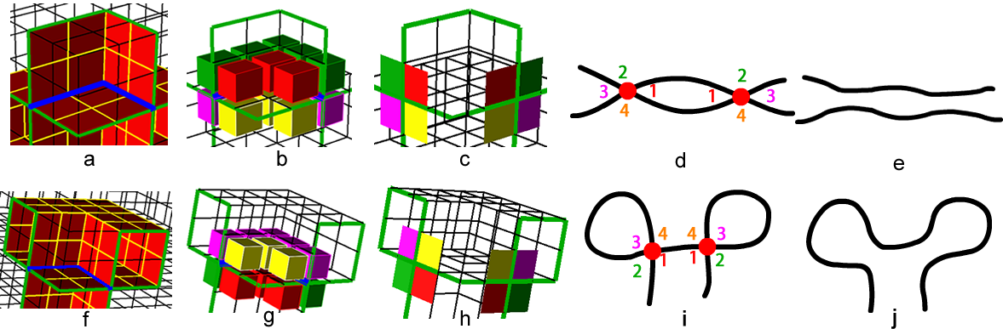Figure 10: Two types of local intersecting structure for pairing intersecting nodes: (a) the 1st local intersecting quad subset; (b) int-4-hex-sets around the 1st local intersecting quad subset; (c) the 1st local intersecting structure of the boundary loop; (d) the pairing information of the 1st local intersecting structure; (e) the 1st local intersecting structure is resolved for recursive searching; (f) the 2nd local intersecting quad subset; (g) int-4-hex-sets around the 2nd local intersecting the quad subset; (h) the 2nd local intersecting structure of the boundary loop; (i) the pairing information of the 2nd local intersecting structure; (j) the 2nd local intersecting structure is resolved for recursive searching.

” (Sec. 3.1)

**Comment 1.12:**

*Line 193-194 "..**.we bring out two templates ..." should be "... we introduce two templates ..."*

**Response:**

Thanks for your suggestion. The sentence has been revised according to your suggestion.

**Comment 1.13:**

*Line 216-217 "The quads in same color ..." should be "The quads of the same color ..."*

**Response:**

Thanks for your suggestion. The sentence has been revised according to your suggestion.

**Comment 1.14:**

*Section 3.3, you need to provide a reference for the "max-flow-min-cut" algorithm. I've never heard of this algorithm before, and I thought you were introducing the algorithm. Later, after googling it, I found and studied it to understand. Please provide a reference so we know where to go to get details.*

**Response:**

Thanks for your comment. The reference for the “max-flow-min-cut” algorithm has been added:

“Lawler E. 4.5. combinatorial implications of max-flow min-cut theorem, 4.6. linear programming interpretation of max-flow min-cut theorem. Combinatorial Optimization: Networks and Matroids 2001;:117– 20”

**Comment 1.15:**

*Regarding the "max-flow-min-cut" algorithm, that is a cornerstone of your paper. If people don't understand that algorithm, they will not understand your paper. I recommend you add some more details on that algorithm to people are not required to go look at references to even understand what you are talking about.*

**Response:**

Thanks for your suggestion. One paragraph has been added to explain what is max-flow, what is min-cut, and what is the relationship between max-flow and min-cut:

“Max-flow-min-cut algorithm is an effective and efficient algorithm to find the minimal cut set in a directed graph[18]. On a directed graph with weighted edges, i.e. a flow graph, the maximum flow is the maximum amount of flow passing from the source (the s node) to the sink (the t node). And the minimum cut is the cut (a partition of the vertices of a graph into two disjoint subsets) where the sum of the edges' weights is minimal. The max-flow-min-cut theorem states that given a flow graph and s and t nodes, the max-flow equals the min-cut.” (Sec. 3.3)

In addition, we add the following sentence in Sec. 3.3 and give a reference to the Ford–Fulkerson method:

“…Specifically, in this work, we use the Ford-Fulkeson method[19] to efficiently compute the maximum flow in a flow graph.”(Sec. 3.3)

**Comment 1.16:**

*Line 285. You have not defined "s node" and "t node". They are defined in the references which talk about "max-flow-min-cut", but you need to define that nomenclature in your paper if you are going to use it.*

**Response:**

Thanks for your comment and suggestion. We add the brief description of s node and t node in the paragraph introducing max-flow-min-cut. S node and t node stand for the source node and sink (or target) node in a flow graph respectively. Please refer to the response to Comment 1.15.

**Comment 1.17:**

*Line 275-276 "...* *into two subsets until reaching ..." should be "... into two subsets before reaching ..."*

**Response:**

Thanks for your suggestion. The sentence has been revised.

**Comment 1.18:**

*Line 296, you say "... we need to construct the directed graph ...". Later on line 314, you say the graph is* *bi-directional. It cannot be both.*

**Response:**

Thanks for your comment. Yes, the word “bi-directional” is a bit of confusing. To eliminate the confusing, the sentence “All of the edges in the graph are bi-directional except the edges adjacent to s and t” has been rephrased as:

“There is one directed edge from s node to each of its adjacent nodes. Similarly, there is one directed edge from each of t node’s adjacent nodes to t node. For each pair of adjacent nodes, , if they are neither s node nor t node, there is a pair of opposite directed edges with the same weight between the two nodes.”

**Comment 1.19:**

*Lines 305-309. It seems that another similar case to this is where you have an edge on the boundary that has only 1 adjacent hex inside the mesh. This could happen on a CAD model edge, but also elsewhere.*

**Response:**

Thanks for your comment. This sentence has been rephrased as below:

“…Additionally, mesh edges whose adjacent quads are all boundary quads should not be added into the boundary loop because it usually results in poor mesh quality if the quad set for sheet inflation contains boundary quads. Hence we group the quads sharing these mesh edges into a single node. For example, q2 and q3 in Fig. 20(c) are grouped into a single node.”(Sec. 3.3)

**Comment 1.20:**

*Section 4.1. You never define what an intersecting line is. You say they are important, and that they must be computed, but you need to add some text to define it (i.e.* *An intersecting line is a piecewise continuous set of edges interior to the hex mesh,* *which connect a pair of intersecting nodes.*

**Response:**

Thanks for your comment and suggestion. We’ve added the following definition of intersecting lines in Sec. 3.1:

“For self-intersecting quad sets, the intersecting line plays a very important role in defining the structures of the quad sets, which is a piecewise continuous set of edges interior to the hex mesh connecting a pair of intersecting nodes.” (Sec. 3.1)

**Comment 1.21:**

*Line 361 "The intersecting line is shown in Fig ..." should be "The intersecting line is shown in blue in Fig ..."*

**Response:**

Thanks for your suggestion. The sentence has been revised.

**Comment 1.22:**

*Lines 420-422 can be made more clear. Please reword to "A mesh edge is called a regular edge if it is inside the mesh and its valence equals 4, or on the boundary of the mesh and its valence equals 3."*

**Response:**

Thanks for your suggestion. This sentence has been reworded.

**Comment 1.23:**

*Line 550, I think the references should be [9,10], not [11,10].*

**Response:**

Thanks for your comment. The references have been corrected.

**For Reviewer 2:**

**Comment 2.1:**

*The caption of Figure 3 shall be more specific, like "Flowchart of the optimized complex sheet inflation". Moreover, "Step 1:" shall be renamed to "Input:", "Step 2" to "Step 1:", etc.*

**Response:**

Thank you for your comments and suggestions. The caption of that figure has been revised, and “Step 1:”, “Step 2” and “Step 3” etc. have also been changed according to your suggestion.

**Comment 2.2:**

*Lines 106-109 in Page 2, I recommend authors using numbers rather than letters to list their three major steps, which then will be consistent with Figure 3.*

**Response:**

Thanks for your suggestion. These letters are changed to numbers.

**Comment 2.3:**

*It is better to include references for the max-flow-min-cut and A* path searching algorithms used in the paper.*

**Response:**

Thanks for your suggestion. The following references to max-flow-min-cut and A* path algorithms are added:

[16] HartPE, NilssonNJ, RaphaelB. A formal basis for the heuristic determination of minimum cost paths. Systems Science and Cybernetics, IEEE Transactions on 1968;4(2):100–7.

[17] Dijkstra EW. A note on two problems in connection with graphs. Nu- merische Mathematics 1959;1(1):269–71.

[18] Lawler E. 4.5. combinatorial implications of max-flow min-cut theo- rem, 4.6. linear programming interpretation of max-flow min-cut theo- rem. Combinatorial Optimization: Networks and Matroids 2001;:117– 20.(Sec. Refences)

[19] Ford LR, Fulkerson DR. Maximal flow through a network. Canadian journal of Mathematics 1956;8(3):399–404.

**Comment 2.4:**

*In Figure 5, what does "E" denote in the flowchart? In the workflow, if we need to call procedure* *"Find and add new edges to E by max-flow-min-cut algorithm", shall we call procedure* *"Does E satisfy local separation?" again before reach to "End"?*

**Response:**

“E” denotes the constraint mesh edges specified by the user. The sentence has been revised to make it clearer:

“…the flowchart of the determination of boundary loops is shown in Fig. 9. Note that E in Fig. 9 denotes the constraint mesh edges specified by the user.”(Sec. 3)

After calling "Find and add new edges to E by max-flow-min-cut algorithm", there is no need to check "Does E satisfy local separation?" because the max-flow-min-cut algorithm will guarantee the local separation.

**Comment 2.5:**

*In "3.1. Pairing Intersecton Nodes", how shall we know when we shall apply Template A or Template B? In other words, what is the criterion of using Templates A and B?*

**Response:**

In the revised version, we have replaced “template” by “local intersecting structures” to make the term more accurate. Please refer to our response to Comment 1.11.

Currently we treat these two types of local intersecting structures equally and use a depth-first strategy to search the boundary loop to identify them. We add the following sentence in Sec. 3.1 to express this meaning:

“…Currently, we treat these two types of local intersecting structures equally and use a depth-first strategy to search and handle them, which means if we find either local intersecting structure, we pair its two intersecting nodes and modify it at once until no more intersecting nodes can be paired.” (Sec. 3.1)

We will investigate better strategy to search and handle the two types of local intersecting structures in the future.

**Comment 2.6:**

*Lines 231-233 in Page 5, authors say that if there is still one intersecting node left unpaired, they will create a new intersecting node. Is this operation (creating a new intersecting node) manual or automatic?*

**Response:**

This operation is automatic. The two types of local intersecting structures provide us with enough topological information to automatically find a new intersecting node. We have revised the figure and paragraphs to explain the automatic procedures of creating the new intersecting node:

“…The creation can be automatic based on the topological information provided by the two types of local intersecting structures.

For example, in Fig. 14(a), the intersecting node A is un- paired. Since a substructure of the 1st intersecting structure can be found in current mesh edges, which contains a closed circle with a single intersecting node, the 1st intersecting structure is used to help us create the second intersecting node. First, we choose either end nodes on the current mesh edges, v in Fig. 14(a) for instance. Second, from v we search for a suitable mesh node to be the second intersecting node B which should meet two requirements: 1) its node valence should be no less than 4 in order to be an intersecting node; 2) the distance be- tween B and v should be relatively equal to len (length from A to v as shown in Fig. 14(b)) to make B and A symmetrical to v which usually enhances the mesh quality. The second intersecting node B is determined in Fig. 14(b). Third, according to the 1st local intersecting structure, the substructure at B is constructed (Fig. 14(c)). At last, to achieve better symmetry, we extend the edge circle adjacent to B to the extent that encloses a similar number of quads as the circle adjacent to A as shown in Fig. 14(d).

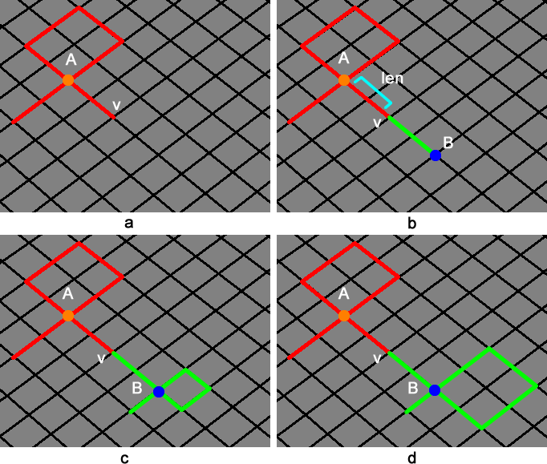

Figure 14: Handling of the situation when single intersecting node is unpaired: (a) intersecting node A is unpaired; (b) the new intersecting node B is determined; (c) the substructure adjacent to B is constructed; (d) the edge circle adjacent to B is expanded according to the size of the edge circle adjacent to A.

”(Sec. 3.1)

**Comment 2.7:**

*Line 364 in Page 7, I think it shall be "hex-sets as shown in Fig. 16(c) & (d)".*

**Response:**

Thanks for your suggestion. It has been corrected.

**Comment 2.8:**

*For Equation (2) in Page 9, it is unclear which "e" is used in "ID(e)"? Shall we use the edge before inflation, after inflation, or the delta between them?*

**Response:**

“e” is the edge before inflation. That’s why we call the process the “evaluation” of inflating the quad set.

**Comment 2.9:**

*Line 554 in Page 11, I recommend using "hex mesh M_a" and "hex mesh M_b" instead of* *"hex mesh 2" and "hex mesh 1".*

**Response:**

Thanks for your suggestion. "hex mesh 2" and "hex mesh 1" are changed to "hex mesh 2" and "hex mesh 1" respectively.

**For Reviewer 3:**

**Comment 3.1:**

*While the results are impressive, the readers may have a difficult time understanding the significance of the approach.*

**Response:**

Thank you for your comments. In order to let the readers understand the significance and motivation of our work better, we’ve enhanced the related contents in the revised version:

1) Add one figure and some sentences at the beginning of the introduction to show why dual operations are important for mesh modification;

2) Add new figures, examples and paragraphs to explain what sheet inflation is and why it is so useful in mesh modification;

3) add another example to demonstrate why it is necessary to handle the generating of self-intersecting sheets.

For the details, please refer to the response to Comment 1.6.

**Comment 3.2:**

*The authors started the paper with the process of generating sheet inflation in the context of hex meshing. There isn't a definition for "sheet inflation".*

**Response:**

Thanks for your comment. We have revised the figure in the introduction to illustrate the process of the sheet inflation and a new paragraph to explain what sheet inflation is.

The revised figure is:



Figure 2: The procedures of sheet inflation: (a) the hex mesh before sheet inflation; (b) the quad set for sheet inflation; (c) the new sheet is created by inflating the quad set; (d) the new sheet is created; (e) the hex mesh after sheet inflation.

The new paragraph for explaining the sheet inflation is:

“Sheet inflation takes a continuous quad set as input and generates a new sheet by inflating the quad set. The process of the sheet inflation is illustrated in Fig. 2. This continuous quad set (Fig. 2(b)) is called the quad set for sheet inflation (or quad set if not ambiguous in the context) which is provided by other procedures or specified directly by the user. Sheet inflation splits the nodes, edges and quads on the quad set (Fig. 2(b)), and then form new hexahedra by connecting corresponding the new nodes (Fig. 2(c) and Fig. 2(d)). The process of the sheet inflation shows that the quad set is critical for sheet inflation because it determines the position, shape and topology of the sheet to be generated by the sheet inflation. And compared with pillowing, sheet inflation is more flexible and versatile, having the potential ability to create any kind of sheets, provided that a suitable quad set can be deter- mined. Therefore, sheet inflation can be used to support various hex mesh modification.” (Sec. 1)

**Comment 3.3:**

*When defining the chords using Figure 20, it is not clear whether there are other types of chords and how two chords can be different.*

**Response:**

Theoretically the two kinds of chords mentioned in our paper, i.e. the chord on a quad mesh and the chord on a quad set for sheet inflation, are the same. The only difference between these two kinds of chords is the chord on a quad mesh is not associated to a sheet (because there are no hexahedra here) while the chord on a quad set for sheet inflation is associated to a sheet (because it resides inside a hex mesh). The paragraph that introduces the chords in Sec. 5.2 has been revised in order to let the readers understand the concept of chord better:

“On a quad mesh, starting from an edge, we can recursively get all the edges that are topologically parallel to this edge. These edges and the adjacent quads form a chord, the dual structure of the quad mesh [4, 23]. Similar to the quad mesh, the quad set for sheet inflation also consists of chords. All of the mesh edges on the boundary loop pairwise belong to one chord. For example, in Fig. 26(b), e1 and e2 belong to the chord c1, and e3 and e4 belong to the chord c2. Theoretically the two kinds of chords, the chord on a quad mesh and the chord on a quad set for sheet inflation, are the same. They are both obtained by recursively searching topologically parallel mesh edges on the quads. The only difference between these two kinds of chords is the chord on a quad mesh is not associated to a sheet (because there are no hexahedra here) while the chord on a quad set for sheet inflation is associated to a sheet (because it resides inside a hex mesh). For example, in Fig. 26(c), e3, e4 and their chords are contained in the sheet s (red). Due to the association with a sheet, a chord on the quad set for sheet inflation can be optimized by searching a new path within that sheet to improve the irregular degrees of its edges. ” (Sec. 5.2)

**Comment 3.4:**

*The techniques are clearly explained, and an introduction section at the beginning that clearly describes all relevant definitions and properties about sheets, sheet inflation, chords, intersections, quad sets and their connections to hex remeshing will make this submission self-contained.*

**Response:**

Thanks for your comment and suggestion. In order to make our paper more self-contained, we have added the definitions and explanations of sheets, sheet inflation and quad set in the introduction section, given the definition of chords in Sec. 5.2, and illustrated the connections between sheet inflation and hex remeshing by Fig. 2, Fig. 4 and Fig. 5. Please refer to the responses to Comment 1.3 ~ Comment 1.6 for the details.

**Comment 3.5:**

*Moreover, there are relatively few comparisons with existing work, and the models used to demonstrate the techniques are rather simple. For example, how well does the technique work for the Stanford Bunny or Buddha? To fully justify the advantages of the approach, rigorous comparisons will be helpful.*

**Response:**

Compared with existing work, our algorithm mainly extends previous sheet inflation algorithms’ ability so that self-intersecting sheets can be locally generated. We have added a new subsection in Sec. Examples to show the comparisons between our approach and existing works:

“6.3. Comparisons with existing works

Results show that our approach can effectively generate complex localized sheets that self-intersect more than once while guaranteeing the mesh quality. Comparisons are made be- tween our approach and existing works including Mitchell’s Pillowing[1], Staten’s General Sheet Inflation[9] and Chen’s Sheet Inflation[14]. Table 1 lists the detailed comparisons be- tween our approach and existing works.

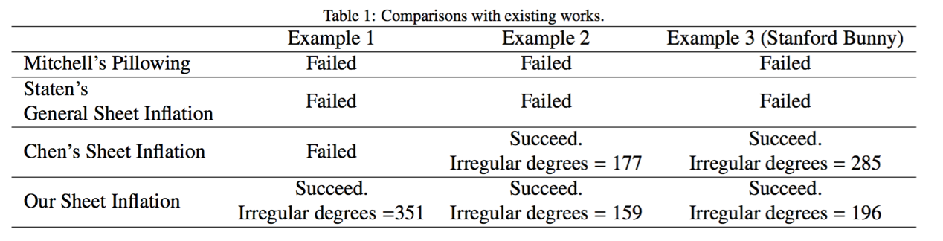

Pillowing fails to handle these three examples because it lacks the ability to generate self-intersecting sheets. Staten’s General Sheet Inflation fails either because it cannot locally generate self-intersecting sheets. Although Chen’s Sheet Inflation can inflate sheets that self-intersect only once, our approach can achieve better mesh quality.

” (Sec. 6.3)

We have also emphasized this point in Sec. Conclusions and Future Work as follows:

“…Compared with previous sheet inflation methods, our approach can effectively generate complex sheets within a local region. The examples show that our approach can locally generate self-intersecting sheets successfully and guarantee the quality of the resultant meshes.” (Sec. 7)

In order to show that our algorithm can work for more complex models, we have added a new test example, i.e. Stanford Bunny. The test results of the example as well as the explanation are given below:

“…We have also tested our algorithm with the famous Stanford Bunny. As shown in Fig. 35, the hex mesh of Stanford Bunny contains two high-valence boundary nodes. To reduce the valences of these two nodes, a sheet inflation is conducted, creating a self-intersecting sheet. The major steps are shown in Fig. 36. And the modification result is shown in Fig. 37, where the high valences of the two nodes are successfully reduced.



Figure 38: Hex mesh of Stanford Bunny with two high-valence boundary nodes.



Figure 39: Process of reducing the high node valences on Stanford Bunny: (a) several boundary edges adjacent to the high-valence nodes are selected as boundary constraints; (b) the boundary loop is constructed; (c) the quad set is constructed; (d) the new sheet is inflated.



Figure 40: The high node valences are reduced by conducting our sheet inflation.

” (Sec. 6)

**Comment 3.3:**

*Lastly, a typo is in "**stands for it valence"; and the sentence "**the main reason for the difficulties is the inherent global connectivity which makes any local modification often .." is incomplete.*

**Response:**

Thanks for your comment. The typo in “stands for it valence” has been fixed, and the sentence has been revised as “The main reason for the difficulties is that local modification inevitably influence the whole hex mesh due to the inherent global connectivity of hex mesh[4, 5, 6, 7].”.

**For Reviewer 4:**

**Comment 4.1:**

*Before diving into the details of the review, I'd like to express a consideration on the cover letter accompanying the manuscript. In the "closest prior art" section the authors identify a previous version of the manuscript (rejected at the 24th IMR) as the state of the art in the field. Firstly, I don't think a rejected paper can be counted as state of the art. Secondly, I've found very funny that the manuscript aims to be, at the same time, both state of the art and a novel contribution over the state of the art for hexahedral mesh sheet generation/inflation. This is quite confusing to me.*

**Response:**

Thank you for your comments. Sorry for not well understanding the submission guides for author of Computers & Graphics. The closest prior art has been changed to “*Chen, J., Gao, S., & Zhu, H. (2015). An improved hexahedral mesh matching algorithm. Engineering with Computers. doi:10.1007/s00366-015-0414-1*. Accepted.”

**Comment 4.2:**

*As far as I understand the novelty of your approach is the ability to handle inflation sheets that self-intersect more than once. What I think is missing is: why self-intersecting sheets are important, and, in what your method is superior to previous methods like e.g. [9] and [10]? Can you show a practical example in which previous methods would fail because they do not handle self-intersecting sheets whereas your method would succeed?*

**Response:**

Thank you for your comments. To show the importance of generating self-intersecting sheets, we add an example in the introduction where a self-intersecting sheet needs inflating to reduce the high valence of a boundary node:

“… Here it should be pointed out that in many situations it is imperative to locally create self- intersecting sheets. For the example in Fig. 6(a), where a nodes valence is 7, splitting method shown in Fig. 3(b) can not effectively reduce the high valence since the valence of one new node is still 6 (Fig. 6(b)). Thus, instead of selecting two adjacent edges, four adjacent edges need to be selected and the node needs to be split into four nodes as shown in Fig. 6(c), which requires a self-intersecting sheet be generated. …



Figure 6: An example when a self-intersecting sheet is required to be generated: (a) the hex mesh with a high-valence node; (b) the high valence is reduced by splitting the node into four nodes.

” (Sec. 1)

Compared with existing work, our approach can generate sheets that self-intersect more than once and localize the modification. Please refer to the response to Comment 3.5 for detailed comparisons between our approach and existing works.

**Comment 4.3**

*Furthermore, the application proposed in Section 6.1 is not quite clear to me; I had to download and read both [10] and [11] to figure out what mesh matching is about. The associated figures don't really help to understand (the wireframe images are almost impossible to read).*

**Response:**

Thank you for your comments. We’ve added new sentences and a figure to explain what mesh matching is and the typical process of mesh matching:

“Mesh matching is an algorithm to convert non-conforming interfaces to conforming ones[14, 15]. Starting from interfaces with different topologies, it gradually changes the interfaces’ topologies by sheet operations until the interfaces’ topologies become identical. The typical process of the mesh matching algorithm is shown in Fig. 29.

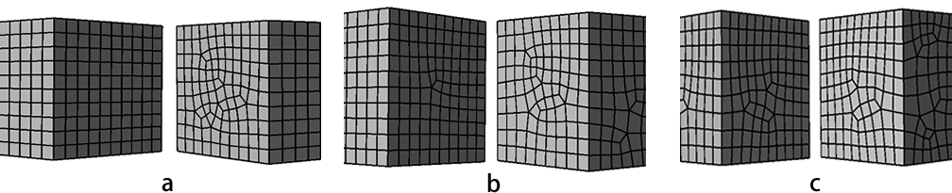

Figure 29: The typical process of mesh matching: (a) non-conformal interfaces; (b) interfaces are changed by sheet operations; (c) non-conformal interfaces are converted to conformal interfaces.

”(Sec. 6.1)

**Comment 4.4:**

*Figure 3 is not very clear as well. It took me a while to spot the difference between step 1 and step 2; I'd suggest to use a different color and maybe a closeup to show the portion of curve that closes the loop. The wireframe shading in step 2 is also very difficult to interpret. The difference between step 3 and 4 is not clear as well; I can see two slightly different quad sets but I don't understand nothing more than this: why the optimized quad set is better than the non-optimized one? I guess in the optimized quad set the overall valence of the edges is lower, but the picture shows none of this. Can you visualize it?*

**Response:**

Thanks for your comment and suggestion. The portion of the curve that closes the loop has been highlighted and annotated. The whole figure has been scaled in order to make the figure clearer. The optimized quad set are better because it has lower irregular degrees of the edges. The irregular degrees of the quad set before and after optimization are explicitly shown in the figure now. The modified figure is shown below:

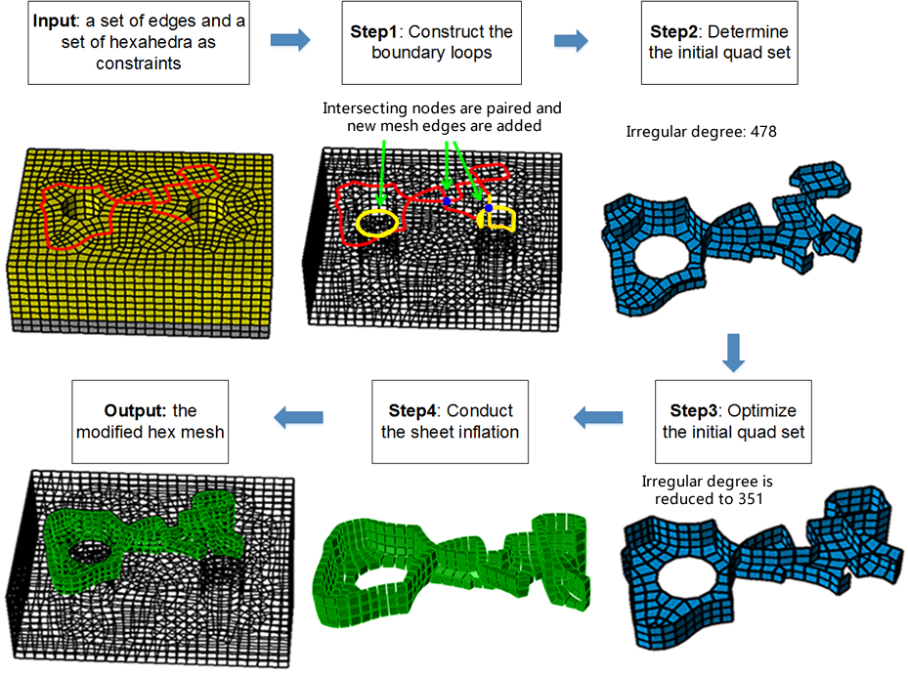

**Comment 4.5:**

*I don't understand why the algorithm is restricted only to loops. It seems to me that a quad set that traverses a shape from left to right separating it in two connected components (or more, if intersecting nodes are present) is a valuable solution in many cases. Am I wrong? Am I missing anything?*

**Response:**

Sorry for not explaining the motivation of our work clearly. In most mesh modification scenarios, the user only wants to locally modify the boundary of a hex mesh. And although the quad set is very important for sheet inflation (sheet inflation and why the quad set is so important for sheet inflation has been explained in the introduction), it is neither necessary nor convenient for the user to select the quad set directly. Obviously, a better way is to let the user select a set of boundary mesh edges as constraint to guide the determination of the quad set. Thus our algorithm provides a solution for constructing the quad set under the user-specified constraints. In order to explain the motivation of our work more clearly, we have added new examples in the introduction section. Please refer to the response to Comment 1.6.

**Comment 4.6:**

*The same goes for a loop with a single intersecting node. Is there any specific reason why this solution is not good? Is it a bad solution for applications or it's your method that cannot handle such case because it does not fit your templates? This is not very clear to me.*

**Response:**

It is impossible to construct a quad set for sheet inflation from a single closed loop with one intersecting node because an intersecting line can only have 0 or 2 intersecting nodes. And the loop with odd number of intersecting nodes is invalid for constructing the quad set for sheet inflation. Thus for the loop with a single intersecting node, we automatically create another intersecting node to pair with it. In order to explicitly express the above meaning, we’ve revised the related content in Sec. 3 as follows:

“…The second characteristic also indicates that each intersecting node on the boundary loop needs another intersecting node to be paired in order to determine an intersecting line, which means there should be an even number of intersecting nodes on the boundary loop. This also indicates that the boundary loop with odd number of intersecting nodes is invalid for constructing the quad set for sheet inflation.” (Sec. 3)

**Comment 4.7:**

*Despite the length of the paper (13 pages) there are not enough technical details. I don't think a student would be able to reproduce your results based on the content of the manuscript. The formalization of both the min-cut and A* problems is missing. Furthermore, how do you edit A* to consider turning angles? Please provide citations and/or an explanation of how you formalize your problems, what are the unknowns and how do you solve for them.*

**Response:**

Thanks for your comment. For max-flow-min-cut algorithm, we’ve added the background of this algorithm and corresponding references. We use Ford-Fulkerson method to solve the max-flow-min-cut problem. And a reference about Ford-Fulkerson method has been added. We also provide detailed information about how to construct the directed graph. The followings are the specific contents added in the revised version:

“Max-flow-min-cut algorithm is an effective and efficient algorithm to find the minimal cut set in a directed graph[21]. On a directed graph with weighted edges, i.e. a flow graph, the maximum flow is the maximum amount of flow passing from the source (the s node) to the sink (the t node). And the minimum cut is the cut (a partition of the vertices of a graph into two disjoint subsets) no more intersecting nodes can be paired. The max-flow-min-cut theorem states that given a flow graph and s and t nodes, the max-flow equals the min-cut.

As shown in Fig. 20(a), to use the max-flow-min-cut algorithm, a directed graph should be constructed with an s node and a t node, and the weights of the edges should also be set before calculation. The algorithm will find a minimal cut set that determines the max flow from s to t.

If we take the boundary of H as a graph where the nodes stand for a quad or a quad set and the edges stand for the adjacency relationship between the quads or quad sets, then to be able to do local separation is similar to find a cut set on this graph. Hence, the max-flow-min-cut algorithm can be used to help us to find necessary edges to make the boundary loop satisfy the local separation. Specifically, in this work, we use the Ford-Fulkeson[22] method to efficiently compute the maximum flow in a flow graph.” (Sec. 3.3)

For A* algorithm, to formally explain how we apply this algorithm, we have added the following figures, paragraphs and references:

“A* path searching is a one-source-one-target path searching algorithm which runs very efficiently [18]. It is an extension of the Dijkstra’s algorithm[19]. The formalization of A* algorithm is shown in Equ. 1. Here, g(n) is the known cost of getting from the initial node to n; this value is tracked by the algorithm. h(n) is a heuristic estimate of the cost to get from n to the target node. For the algorithm to find the actual shortest path, the heuristic function h(n) should never overestimate the actual cost to get to the target node.

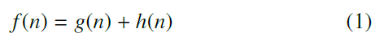

Given two boundary mesh edges e1 and e2 and their common mesh node v, e1 and e2 separate v’s adjacent quads into to quad subsets Q1 and Q2. The turning angle in this paper is the quad number variance between these two quad subsets, which can be calculated by Equ. 2 where ||Q1|| and ||Q2|| stand for the number of quads in Q1 and Q2 respectively.

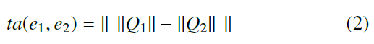

For example, in Fig. 15a, Q1 and Q2 contain 1 and 3 quads respectively. So ta(e1, e2) = 2. In Fig. 15b, Q1 and Q2 both contain 2 quads. So ta(e1,e2) = 0.

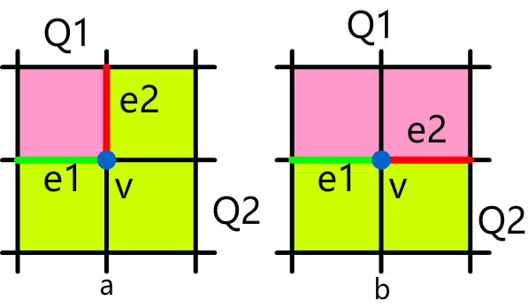

Figure 15: Turning angles between two boundary mesh edges: (a) the two edges separate the v’s adjacent to two quad subsets and ||Q1|| = 1 and ||Q2|| = 3; (b) the two edges separate the v’s adjacent to two quad subsets and ||Q1|| and ||Q2|| are both 2.

When applying A* algorithm, in addition to considering the count of mesh edges on the path, we also take the angles between adjacent edges on the path into consideration. This is necessary because if the turning angles are large, the mesh quality, especially the boundary mesh quality, will degenerate. Therefore, suppose the current mesh edges are E, the determined part in A* algorithm can be calculated using Equ. 3 where ||E|| stands for the number of edges in E. The weight  controls the magnitude of how the turning angle impacts on the searching result. Usually  = 1 is feasible.

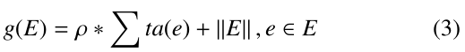

For the heuristic part of A*, we use a breadth-first strategy to estimate at least how many mesh edges are needed to be traversed from current node to the target node. Since the breadth-first estimation only takes the number of traversed edges into consideration, it meets the requirement in A* algorithm that h(n) should never overestimate the actual cost to get to the target node. For example, after conducting a breadth-first iteration, the minimum numbers of mesh edges that are needed to be traversed from a given mesh node to v1are shown in Fig. 16a. Therefore h(v2)= 2 and h(v3)= 4.

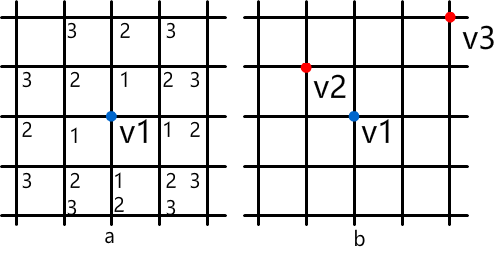

Figure 16: Estimation for the heuristic distance between two nodes: (a) the minimum distances are calculated by using a breadth-first iteration; (b) the heuristic distances of v2 and v3 regarding to v1 are 2 and 4 respectively.

” (Sec. 3.2)

**Comment 4.8:**

*From the abstract: "it is still difficult to generate self-intersecting sheet within a local region while assuring the mesh quality." and "Our approach can generate complex sheets that intersect themselves more than once and guarantee the quality of the resultant mesh" - Mesh quality is a quite vague concept; there are different metrics to measure quality, and the definition you stick to is just one among many other possible definitions. Please either rephrase or be more precise.*

**Response:**

Yes, there are many different metrics to measure quality of a quad set or a sheet. To explicitly tell the readers how we measure the quality, we have added the following sentence in the introduction section:

“…Since the edge valences (the number of the quads that are adjacent to the edge) have significant impact on the quality of quad mesh and hex mesh [15], we use the irregular degrees (the edge’s valence variance from a regular edge) of the quad set[17] to measure its quality in this work.” (Sec. Introduction)

Finally, it is our pleasure to have our paper being considered to publish in Computers & Graphics. Please do not hesitate to contact us if you need further information or work.

Sincerely yours,

The authors